Cloud Spanner: Qwik Start
30 minutes1 Credit

Rate Lab

GSP102

Overview
Cloud Spanner is a fully managed, mission-critical, relational database service that offers transactional consistency at global scale, schemas, SQL (ANSI 2011 with extensions), and automatic, synchronous replication for high availability.
Cloud Spanner offers:
- Strong consistency, including strongly consistent secondary indexes.
- SQL support, with ALTER statements for schema changes.
- Managed instances with high availability through transparent, synchronous, built-in data replication.
Cloud Spanner offers regional and multi-region instance configurations.

What it's good for
Cloud Spanner is ideal for relational, structured, and semi-structured data that requires high availability, strong consistency, and transactional reads and writes.

Other storage options
Here are some common scenarios where you should probably consider an alternative to Cloud Spanner:
- If you do not want a strongly consistent and horizontally scaling relational database. Consider other storage offerings listed at Storage Options in Google Cloud Platform and Data Lifecycle on Google Cloud Platform.
- If you need an open source database.
This hands-on lab shows you how to create a Cloud Spanner instance, database, and table; add a schema, write and modify data, and run a query.

Setup and Requirements

Qwiklabs setup

Before you click the Start Lab button
Read these instructions. Labs are timed and you cannot pause them. The timer, which starts when you click Start Lab, shows how long Cloud resources will be made available to you.
This Qwiklabs hands-on lab lets you do the lab activities yourself in a real cloud environment, not in a simulation or demo environment. It does so by giving you new, temporary credentials that you use to sign in and access the Google Cloud Platform for the duration of the lab.

What you need
To complete this lab, you need:
- Access to a standard internet browser (Chrome browser recommended).
- Time to complete the lab.
Note: If you already have your own personal GCP account or project, do not use it for this lab.

How to start your lab and sign in to the Console
- Click the Start Lab button. If you need to pay for the lab, a pop-up opens for you to select your payment method. On the left is a panel populated with the temporary credentials that you must use for this lab.
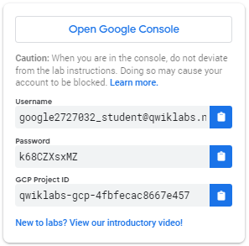
- Copy the username, and then click Open Google Console. The lab spins up resources, and then opens another tab that shows the Choose an account page.
Tip: Open the tabs in separate windows, side-by-side.
- On the Choose an account page, click Use Another Account.
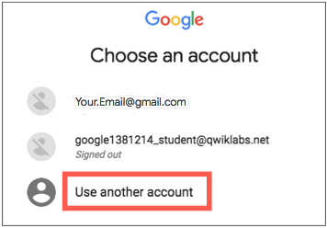
- The Sign in page opens. Paste the username that you copied from the Connection Details panel. Then copy and paste the password.
Important: You must use the credentials from the Connection Details panel. Do not use your Qwiklabs credentials. If you have your own GCP account, do not use it for this lab (avoids incurring charges).
- Click through the subsequent pages:
  - Accept the terms and conditions.
  - Do not add recovery options or two-factor authentication (because this is a temporary account).
  - Do not sign up for free trials.
After a few moments, the GCP console opens in this tab.
Note: You can view the menu with a list of GCP Products and Services by clicking the Navigation menu at the top-left, next to “Google Cloud Platform”. 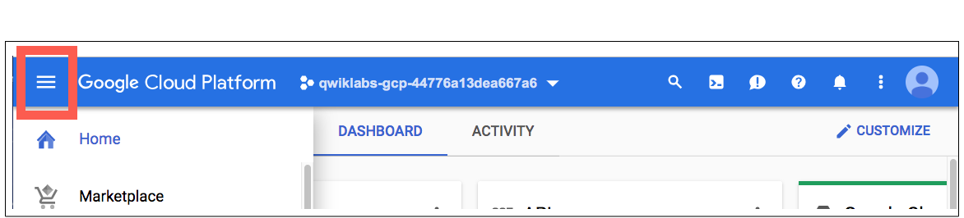

Create an instance
When you first use Cloud Spanner, you must create an instance, which is an allocation of resources that are used by Cloud Spanner databases in that instance.
In Google Cloud Platform, click Navigation menu > Spanner > Create instance.
Fill in the following fields:
Name: Test Instance.
Select regional configuration and from the drop-down menu select region as us-central1.
Your instance creation page now looks like this:
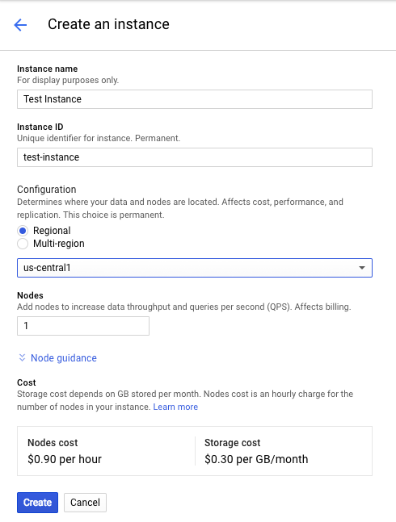
Click Create. This will take a little while to complete.
You'll now see your instance on the Instance Details page.

Create a database
- Click Create database.
- For the database name, enter example-db, then click Continue.
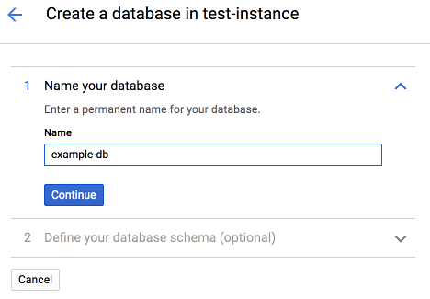
- Skip the Define your database schema step for now. You'll define your schema in the next section.
- Click Create.
You're now on the Database details page for the new database you created.
Click Check my progress to verify the objective.
Create an instance and database
Check my progress

Create a schema for your database
The Cloud Platform Console provides two ways to create, alter, and delete tables and indexes in a database:
- Use the default Database editor to specify each part of tables, columns, and indexes.
- Switch the editor to the Edit as text mode and enter SQL statements in Cloud Spanner Data Definition Language (DDL) syntax.
This lab uses DDL.
On the Database Details page for your example-db database, do the following:
- Click Create table.
- Click the Edit as text toggle.
- In the DDL statement field, enter:
- CREATE TABLE Singers (
- SingerId INT64 NOT NULL,
- FirstName STRING(1024),
- LastName STRING(1024),
- SingerInfo BYTES(MAX),
- BirthDate DATE,
- )PRIMARY KEY(SingerId);
- Click Create. This may take a few minutes to finish. When the operation is complete, the Cloud Platform Console displays the details of the table that you created:
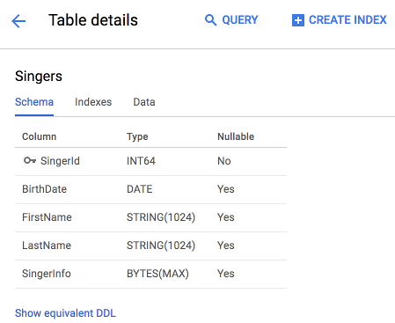
Click Check my progress to verify the objective.
Create a schema for your database
Check my progress

Insert and modify data
The Cloud Platform Console provides an interface for inserting, editing, and deleting data.

Insert data
- In the left pane of the Console, click Singers then click Data.
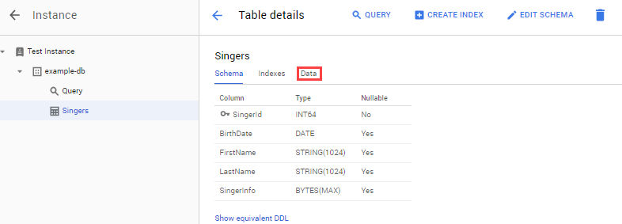
- Click Insert.
- Enter the values for the following fields:
Field | Value
SingerID: INT64 | 1
BirthDate: DATE | [leave blank]
FirstName: STRING | Marc
LastName: STRING | Richards
SingerInfo: BYTES | [leave blank]
- Click Save.
The Singers table now has one row:
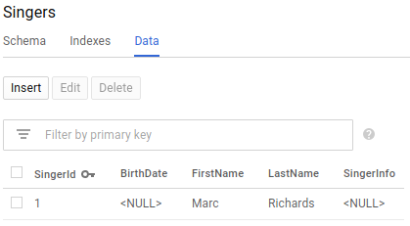
- Click Insert to add an additional row and enter the following:
Field | Value
SingerID: INT64 | 2
BirthDate: DATE | [leave blank]
FirstName: STRING | Catalina
LasteName: STRING | Smith
SingerInfo: BYTES | [leave blank]
- Click Save.
The Singers table now has two rows:
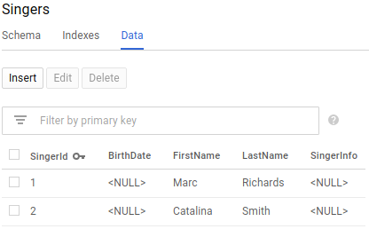
You can also insert empty string values when you enter data.
- Click Insert.
- Enter the following:
Field | Value
SingerID: INT64 | 3
BirthDate: DATE | [leave blank]
FirstName: STRING | Kena
LasteName: STRING | [check empty string box]
SingerInfo: BYTES | [leave blank]
- Click Save.
- The Singers table now has three rows, and the row for __SingerID __3 has a LastName that is an empty string:
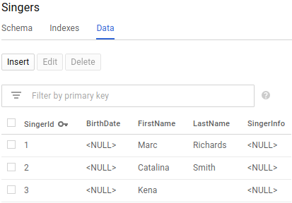

Edit data
Still working on the Singers table, do the following:
- Check the box next to the row for __SingerId __3, then click Edit.
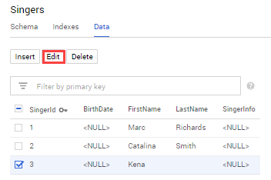
- Enter the following:
Field | Value
BirthDate: DATE | 1961-04-01
[all other fields] | [leave as-is]
- Click Save.
- The row for __SingerId __3 in the Singers table now has a BirthDate value:
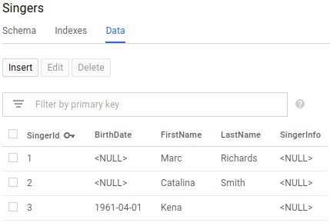

Delete data
Now try deleting some data from the table.
- Check the box next to the row for __SingerId __2, then click Delete.
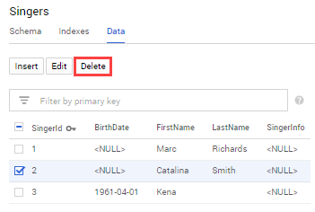
- In the dialog that appears, click OK.
- Click Save.
- The Singers table now has two rows:
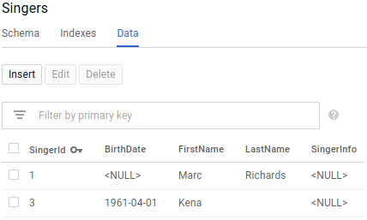

Run a query
You can execute a SQL statement on the query page of your database.
In the left pane of the Cloud Platform Console, click example-db to navigate to the Database details page, then click "Query".
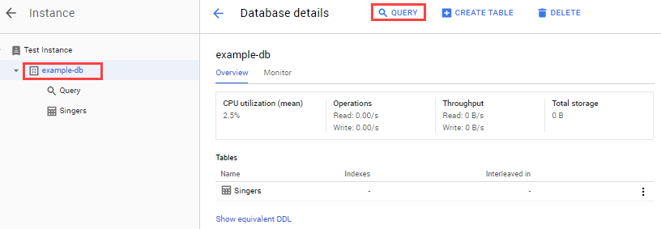
For the query enter:
SELECT * FROM Singers
Click Run query.
The Cloud Platform Console displays the result of your query:
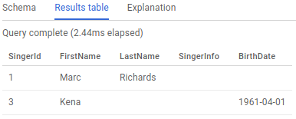
Congratulations! You've successfully created a Cloud Spanner database and executed a SQL statement using the query editor!

Test your knowledge
Test your knowledge about Google cloud Platform by taking our quiz. (Please select multiple correct options if necessary.)
Google Cloud Spanner is a Mission-critical, relational database service with transactional consistency, global scale and high availability.
True

False

Congratulations!

